Supernatural Enemies Affect Outgroup Attitudes through Strength of Human Identity?
A Conceptual Replication of Ellithorpe et al. (2018)

Shay Xuejing Yao, Morgan E. Ellithorpe, David Ewoldsen, and Lanier Holt

Author Note
Shay Xuejing Yao, Ph.D., Assistant Professor, Department of Communication, Georgia State University, Atlanta, GA, 30303, U.S., shayyao@gsu.edu
Morgan E. Ellithorpe, Ph.D., Assistant Professor, Department of Communication, University of Delaware, Newark, DE, 19716, U.S., mellitho@udel.edu
David Ewoldsen, Ph.D. Professor, Department of Media & Information, Michigan State
University, East Lansing, MI, 48823, U.S., ewoldsen@msu.edu
Lanier Holt, Ph.D., Associate Professor, Department of Communication, Ohio State University, Ohio, U.S., holt.341@osu.edu

Abstract
Previous research investigated how a shared human identity may promote interracial inclusion in the context of mass media (Ellithorpe et al., 2018). The original study found promising results of reduced intergroup prejudice through watching the supernatural genre. However, the original results had mixed support to theory, i.e., the Common Ingroup Identity Model (CIIM). To test whether the expected and unexpected results of Ellithorpe et al. (2018) would exhibit again with a different sample, we replicated and extended this research. The overall pattern of our findings is consistent with the original study, in that we again found a cross-over interaction between human identity cues (human villains vs. non-human villains) and diversity cues (all-White heroes vs. racially diverse heroes) on the strength of human identity. Participants reported stronger human identity when watching racially diverse heroes fighting against non-human villains compared to human villains. Participants also reported stronger human identity when watching White heroes fighting against human villains compared to non-human villains. However, we are hesitant to claim that Ellithorpe et al.’s results were fully replicated in our research as most simple main effects of group comparisons were statistically nonsignificant. Overall, our findings offered limited support to Ellithorpe et al.’s original study and minimal support to CIIM. Our experiment also extended the original research. We found that the impact of watching supernatural genre on ingroup relationship may be more likely to work through reduced negative attitudes rather than increased positive attitudes.
Keywords: media effects; common ingroup identity; prejudice; race; replication research

Supernatural Enemies Affect Outgroup Attitudes through Strength of Human Identity?
A Conceptual Replication of Ellithorpe et al. (2018)
From Sleepy Hollow to The Walking Dead, the supernatural genre on television has received immense popularity in the past decade. The Walking Dead, which features zombies as the major threat to the main characters, attracted more than 10 million viewers for six of its 11 season premieres (e.g., Thumbore, 2017). In addition, this long-running series is ranked as one of the most-watched TV shows of 2020-21 (Schneider, 2021). There are other examples of supernatural and science fiction series with non-human characters drawing large audiences, such as Stranger Things, Supernatural, and American Horror Story (Pennington et al., 2020). Notably, many of these supernatural series include cast members from diverse racial and ethnic backgrounds to portray the human heroes. The supernatural genre’s high popularity and the nature of its content means that the genre has the potential to promote diversity and inclusion in our society. However, despite the supernatural genre’s potential impact on combating intergroup conflict, there is limited research on the genre and its influence on viewers. For example, one previous study found that exposure to supernatural genre content with racially diverse heroes and non-human enemies was associated with reduced prejudice toward racial outgroups (Ellithorpe, et al., 2018). However, more research is needed to replicate and build upon this previous work.
Ellithorpe et al. was among the first to apply the common ingroup identity model (CIIM; Gaertner & Dovidio, 2000) to media psychology research and validated the role of human identity in reducing interracial prejudice in a mediated context. This study also has strong practical relevance in that it tested a way to potentially promote interracial inclusion with one type of media content (i.e., supernatural genre) that is popular among the general population.
The CIIM predicts one possible mechanism through which intergroup prejudice may be altered – recategorization of identity with a common ingroup (Gaertner & Dovidio, 2000). The model states that changes in environmental or perceptual cues can change cognitive representations of groups. These cognitive representations can involve seeing people as just individuals without group affiliations (i.e., the personal identity level in self-categorization theory), as members of two separate groups (e.g., racial groups like White people and Black people), or as members of one larger group which is inclusive of the two subgroup-level separate groups (e.g., the human category is inclusive of all White people and Black people). The CIIM predicts that one way to reduce prejudice is through exposure to cues that remind individuals of the larger, more inclusive group (i.e., human category). When the superordinate identity category is salient, individuals may change their cognitive representations of two separate groups into one new and inclusive ingroup (e.g., from White people as ingroup and Black people as outgroup to all humans as ingroup). Thus, intergroup prejudice is expected to be countered as members of the former outgroup now becoming part of the new, common ingroup. Dovidio et al. (2007) noted that the recategorization process may involve more of a dual identity, rather than a total disappearance of the original identities. For the recategorization process to counter intergroup prejudice, the common ingroup may become the individual’s most salient identity but the subgroup identity remains at least somewhat salient.
Drawing from the CIIM, Ellithorpe and colleagues (2018) tested two types of cues (human identity cue and diversity cue) that could stimulate recategorization with the common ingroup (i.e., the superordinate human category) in the context of the supernatural genre. First, the villain was manipulated to be human or non-human, with the non-human villains pre-tested as either similar to humans (e.g., vampires) or dissimilar to humans (e.g., aliens). They also manipulated the presence of diversity cues for the human characters (the main hero was White vs. Black). They found a cross-over interaction between human identity cues and diversity cues. Compared to participants who read a story about White heroes fighting non-human creatures, those who read about racially diverse heroes fighting non-human villains reported stronger human identity. Evidence of ingroup favoritism was found in Ellithorpe et al.- as the strength of human identity increased, prejudice toward Black individuals decreased. They also found a generalization effect where prejudice toward other social groups that were not featured in the story also decreased.
Ellithorpe et al.’s results largely supported CIIM theory except for one finding – compared to watching White heroes fighting against non-human villains, participants who watched White heroes fighting against other humans reported stronger human identity. This finding contradicts CIIM, which predicts that watching their human ingroup fighting against non-human outgroup should remind individuals that being a human is their superordinate ingroup, not seeing humans fighting other humans. However, in Ellithorpe et al., participants showed stronger identification with the superordinate human group when they saw a fight between White humans and other humans compared to a fight between White humans and non-humans. Therefore, replication research is needed to investigate whether such an unexpected finding would persist in a different sample. We conceptually replicated Ellithorpe et al. with a larger, national U.S. adult sample (the original study used a student sample with a smaller sample size) which provides more adequate statistical power as well as increased generalizability of the results. In our study, if the unexpected finding disappeared, it would mean that the original finding was possibly due to sample-specific issues. If the unexpected finding persisted, it would strengthen Ellithorpe et al.’s original finding and speak more to the theoretical implications regarding CIIM.
The Present Study
See Figure 1 for the hypothesized model. The present design conceptually replicated Ellithorpe et al. (2018) with the same set of predictions and a few extensions to improve and expand upon methods. First, the original study used a transcript of a fighting scene as stimulus and photographs to manipulate both human and diversity cues. This design, though offering strong experimental control, may potentially bias audience responses to visual cues and character identities by removing the formal features of television. Therefore, our study used audiovisual scenes taken from a TV series (The Walking Dead) as stimuli, and human and diversity cue manipulations were both embedded within the videos. Watching scenes from an existing TV show should better approximate the way audiences experience media content in their everyday life, increasing mundane realism. We chose The Walking Dead as stimulus material for two reasons: (1) this TV series has been ranked on IMDB as one of the most watched TV shows in history (zsoka-60620, 2019), and (2) the racially diverse cast and storyline of the series make it possible to select multiple fighting scenes for each experimental condition.
The second change was that the original study used a college student sample, while we used a national U.S. adult sample. Third, the present experiment extended Ellithorpe et al. by seeking a more nuanced understanding of how a salient common ingroup identity influences attitudes toward the target subgroup-level outgroup. The original study used single-item feeling thermometers to capture attitudes toward Black individuals as the focal outcome. We utilized a more detailed measure that captures positive and negative attitudes separately (the positive and negative attitudes toward Blacks scale, Katz & Hass, 1988) to test whether the patterns would differ according to different attitude valence with a more complex scale measure. Previous research has found differed patterns in positive and negative attitudes due to media exposure (Pittinsky et al., 2011), thus this design should offer more complexity in our understanding of the focal research.
Method
Participants
The present study used a 2 (human identity cues: villains as non-human vs. human) by 2 (diversity cues: present vs. absent) between-subjects design. A power analysis was computed with G*Power (Version 3.1; Faul et al., 2009) using the effect size of the interaction effect on strength of human identity (f²=0.0638) from Ellithorpe et al. (2018), which yielded a required sample of 207 participants for 80% power at alpha at .05, two-tailed. Due to previous experience with online surveys using video stimuli, we were concerned about large attrition in usable responses and as a result oversampled. Participants (n=564) were adult U.S. residents recruited from Qualtrics Panels and were compensated according to their agreement with Qualtrics. The present study aimed to test the CIIM using Black individuals as the target outgroup, thus Black participants (n=12) and those who did not report a racial identity (n=2) were removed from analysis. Additionally, because all videos are longer than 120 seconds, participants who spent less than 120 seconds watching the video were disqualified from the study (n=231). Lastly, duplicate IP addresses (n=2) and incorrect responses to attention check (n=58) were removed from analysis, which left a total of 259 responses to test the hypotheses (56% female, M_{age}=51.10, SD_{age}=15.85). The racial breakdown was 81% White, 10% Asian, 2% Hispanic, 1% American Indian or Alaska Native, 2% participants selected more than one race, and 1% indicated “other.” The present study was approved by the Institutional Review Board at Michigan State University.
Design
In the current study, diversity cues were manipulated by the race of the heroes in the video, where diversity cues are present when at least one of the heroes were Black and absent when all heroes in the video were White (determined by a triangulation of actor/actress racial identity, character racial identity, and phenotype). Human identity cues were manipulated by using clips where the villains were humans or zombies.
Each stimulus video included a fighting scene from The Walking Dead. We sampled all fighting scenes from season two to season eight (n=232) and coded each of them into one of the following four categories: (1) Diverse heroes fighting zombies, where the heroes include at least one Black character and one White character. All villains of the scene are zombies. (2) White heroes fighting zombies, where the heroes are White humans only and the villains of the scene are zombies only. (3) Diverse heroes fighting humans, where the heroes include at least one Black character and one White character. (4) White heroes fighting humans, where the heroes are White humans only and the villains of the scene are humans only. (5) Other. Through coding the fighting scenes, we found 83 scenes where diverse heroes fought zombies, 56 scenes where White heroes fought zombies, 42 scenes where diverse heroes fought humans, and 50 scenes where White heroes fought humans. Two video stimuli were selected from each category so that the eight videos have similar length (range=2’09” to 3’31”). The race of all human villains was White in the stimuli videos. The number and racial combination of the human heroes were also balanced to be equivalent across each condition as much as possible.
Measures
Strength of human identity was measured with a seven-point Venn diagram with a larger number means stronger identification with the human category (Gómez et al., 2011; see Table 1 for descriptive statistics). Attitudes toward Black individuals were measured with the 20-item Positive and Negative Attitudes Toward Blacks Scale (Katz & Hass, 1988). Ratings of other identity groups were measured with “feeling thermometers” for four social groups (i.e., Arabs, Latinos, Asians, Atheists). The average score of all ratings was used in subsequent analysis. Lastly, prior exposure to The Walking Dead was measured and controlled as a covariate.
Results
Hypotheses were tested using path analysis with the lavaan package (Version 0.6-12; Rosseel, 2012) in R (Version 4.2.1). All variables in the model were compiled, thus a saturated model was tested with observed variables only, meaning no fit indices are available to report. See Table 2 for path results.
Similar to Ellithorpe et al. (2018), a cross-over interaction was found between human identity cues and diversity cues on strength of human identity (Figure 2). Participants who watched White heroes fighting human villains reported stronger human identification than those watched White heroes fighting non-human villains. Different from the original study, increased strength of human identity when watching diverse heroes fighting non-human villains compared to watching diverse heroes fighting human villains was statistically nonsignificant. When watching non-human zombies as villains, participants reported stronger human identity racially diverse heroes than all-White heroes. However this difference was not statistically significant and thus did not support Ellithorpe et al.
Additionally, we found that increased human identity strength only decreased negative attitudes toward Black people but did not increase positive attitudes. A significant moderated serial mediation was found. Watching all-White heroes fighting against other humans was associated with a stronger human identity compared to all-White heroes fighting against zombies, which was in turn associated with weaker negative attitudes toward Black individuals.
Discussion
The present findings offered limited support to Ellithorpe et al. (2018) and minimal support to the CIIM. We found an interaction with similar patterns that was found in the original study. However, when watching racially diverse heroes, participants’ identification with the human identity was nonsignificant between human and non-human villains. Additionally, when watching human heroes fighting non-human villains, the difference between all-White heroes and racially diverse heroes on human identity was statistically nonsignificant.
Consistent with the original study, we found stronger human identity when participants were exposed to all-White heroes fighting human villains compared to non-human villains, but this finding was against the prediction of CIIM. Stronger human identity induced by watching White heroes fighting other humans could potentially be explained by participants’ perception of the superordinate human identity. Previous CIIM research has demonstrated that the majority group (e.g., White people) tends to see the common ingroup (e.g., humans) as representing their own subgroup-level values and characteristics (e.g., Devos & Banaji, 2005). In our study participants watched a short video with White heroes fighting other humans, and immediately after they were pressed to report their identification level with the human category. Without the presence of diversity cues and non-human villains, it is possible that their reported identification with the human identity in fact represents more of their subgroup-level identity (e.g., White racial group).
Strength of human identity was associated with decreased negative attitudes toward Black people, which was associated with more positive attitudes toward other identity groups. This finding supports CIIM that increased identification with the common ingroup identity reduces outgroup prejudice, and this decreased prejudice toward the target outgroup can be generalized to other outgroups. This finding also extended Ellithorpe et al. (2018) by parsing out the roles between positive and negative attitudes. In our study, the recategorization process worked only through reduced negative attitudes toward the outgroup but not increased positive attitudes. On the one hand, the relationship between human identity and negative attitudes toward Black individuals is highly consistent with previous CIIM findings (e.g., Nier et al., 2001). On the other hand, the nonsignificant relationship between human identity and positive attitudes toward Black individuals also makes sense given that Katz and Hass’ (1988) scale is based on the assumption that White individuals often have ambivalent attitudes toward Black people. When the outgroup is recategorized as ingroup, social identity theory (Tajfel & Turner, 1986) predicts that the negative features of these former outgroups would be diminished. In other words, by the outgroup becoming a part of the ingroup, negative attitudes toward that group are no longer salient because it would pose a threat to the individual’s self-esteem (e.g., my ingroup has these negative characteristics). In this vein, positive attitudes toward outgroups may not change significantly after recategorization because positive characteristics pose no threat to the individual’s self-esteem as a fellow group member.
Limitations and Future Research
We used audiovisual material as stimuli in the current study. However, because we have less control over the stimuli, some issues may confound our results. First, the human-identity-cue factor had two conditions (human vs. non-human villains) in the present experiment but in the original study it had three conditions based on the creatures’ similarity to humans (human, similar to human, dissimilar to human). Specifically, zombies were the non-human villains in this experiment, but in Ellithorpe et al. (2018) it was in the “similar to human” condition. Consequently, the manipulation in the current study is weaker than in the original study. Although the overall interaction between human identity cues and diversity cues was still significant in this experiment, this weaker manipulation may explain the nonsignificant group comparisons. Additionally, rather than a student sample in the original study we used an adult sample and the measure of attitudes toward Black individuals in our study is also different from Ellithorpe et al. Given all this, we caution the readers to interpret our results as a conceptual replication rather than a direct replication. Second, because we selected all stimuli from a TV series, we were limited by the storyline and it was challenging to find fighting scenes with one White character and one Black character as heroes and other humans as villains. Thus, the two stimulus videos for this experimental condition each includes two White characters, one Black character, and an Asian character. Character race was balanced within the condition, but we acknowledge that an additional character racial identity in the video could be a confound. Lastly, we used a posttest-only design in the current research. Although this design should effectively detect the differences between experimental conditions, a pretest and posttest design may provide richer information regarding the effect sizes of exposure to a particular type of media content. To maintain scientific rigor of this line of research, we encourage future research to utilize more pretest and posttest design.
The selection of a popular TV series such as The Walking Dead may pose unique challenges. For example, some heavy viewers of the show are already very familiar with the diversity of the cast, and they may be reminded of the ethnic diversity of the characters merely by being exposed to the show’s content regardless of which diversity cues condition they were in. Additionally, if priming is part of the process by which category salience is increased which is consistent with CIIM’s assumption that people’s default categorization is the group level, then the effect of making the “human” category more salient will fade over time, even without any attempt to make the group-level category more salient. Although the exact time scale of the fading of a prime varies across different domains, it is agreed upon that the effect of a prime fades across time unless the category is made chronically accessible through repeated exposures (Ewoldsen & Rhodes, 2019). Future research should test the effect of time on making the “human” category salient.
Conclusion
Using mass media content to promote positive intergroup relationship has increasingly drawn attention from communication researchers. However, the potential of one particular genre – the supernatural narratives – on promoting diversity and inclusion is still understudied. The present study conceptually replicated and extended Ellithorpe et al. (2018), through which we found limited support for the original study, though the overall pattern of the interaction did replicate. Thus future research is encouraged to continue investigating the unique feature of non-human villains in media narratives as a possible human identity cue, and its potential positive impact on reducing intergroup conflict when coupled with racially diverse casts. Future scientific researchers and media content producers should continue exploring how the supernatural genre as well as other types of media content may induce a shared human identity, and the role of the shared human identity in promoting interracial inclusivity.
References
Ellithorpe, M. E., Ewoldsen, D. R., & Porreca, K. (2018). Die, foul creature! How the supernatural genre affects attitudes toward outgroups through strength of human identity. Communication Research, 45(4), 502-524. https://doi.org/10.1177/0093650215609674
Ewoldsen, D. R., & Rhodes, N. (2019). Media priming and accessibility. In Oliver M. B., Raney A. A., & Bryant J. (Eds.), Media effects (4th ed., p. 83-99). Routledge.
Faul, F., Erdfelder, E., Buchner, A., & Lang, A.-G. (2009). Statistical power analyses using G*Power 3.1: Tests for correlation and regression analyses. Behavior Research Methods, 41, 1149-1160.
Gaertner, S. L., Dovidio, J. F., Nier, J. A., Banker, B. S., Ward, C. M., Houlette, M., & Loux, S. (2000). The common ingroup identity model for reducing intergroup bias: Progress and challenges. In D. Capozza & R. Brown (Eds.), Social identity processes: Trends in theory and research (pp. 133-148). Thousand Oaks, CA: Sage.
Gómez, A., Tropp, L. R., & Fernández, S. (2011). When extended contact opens the door to future contact: Testing the effects of extended contact on attitudes and intergroup expectancies in majority and minority groups. Group Processes & Intergroup Relations, 14, 161-173. doi:10.1177/1368430210391119
Katz, I., & Hass, R. G. (1988). Racial ambivalence and American value conflict: Correlational and priming studies of dual cognitive structures. Journal of Personality and Social Psychology, 55(6), 893.
Nier, J. A., Gaertner, S. L., Dovidio, J. F., Banker, B. S., Ward, C. M., & Rust, M. C. (2001). Changing interracial evaluations and behavior: The effects of a common group identity. Group Processes & Intergroup Relations, 4, 299-316. doi:10.1177/1368430201004004001
Pittinsky, T. L., Rosenthal, S. A., & Montoya, R. M. (2011). Liking is not the opposite of disliking: The functional separability of positive and negative attitudes toward minority groups. Cultural Diversity and Ethnic Minority Psychology, 17(2), 134. doi: 10.1037/a0023806
Rosseel, Y. (2012). Lavaan: An R package for structural equation modeling and more. Version 0.5–12 (BETA). Journal of statistical software, 48(2), 1-36. https://doi.org/http://dx.doi.org/10.18637/jss.v048.i02
Tajfel, H., & Turner, J. (1986). The social identity theory of intergroup behavior. In S. Worchel & W. Austin (Eds.), Psychology of intergroup relations (pp. 7-24). Chicago, IL: Nelson.

Figure 1
Hypothesized Model
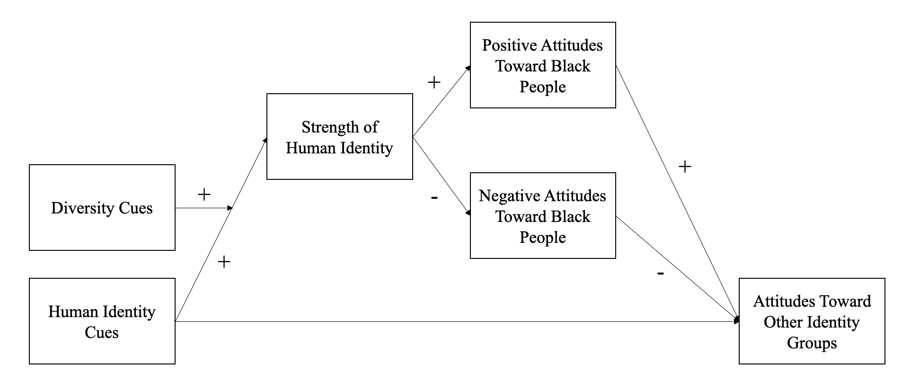

Table 1

Descriptive Statistics and Correlation Matrix

 |  |  |  |  | 1 | 2 | 3 | 4 | 5 | 6 | 7 | 8
Variable | M | SD | Range | Cronbach’s α
1. Strength of Human Identity | 5.22 | 2.23 | [1, 7] | - | -
2. Positive Attitudes toward Black People | .53 | 1.82 | [-5, +5] | .85 | -.005 | -
3. Negative Attitudes toward Black People | -.21 | 1.93 | [-5, +5] | .88 | -.11 | -.25 | -
4. Ratings of Other Identity Groups (Latino People) | 68.52 | 28.71 | [1, 100] | - | .17 | .21 | -.35 | -
5. Ratings of Other Identity Groups (Asian People) | 69.60 | 28.24 | [1, 100] | - | -.01 | .24 | -.31 | .52 | -
6. Ratings of Other Identity Groups (Arab People) | 56.49 | 32.49 | [1, 100] | - | .16 | .28 | -.42 | .73 | .54 | -
7. Ratings of Other Identity Groups (Atheists) | 54.74 | 33.52 | [1, 100] | - | .18 | .16 | -.29 | .79 | .53 | .73 | -
8. Ratings of Other Identity Groups (all four groups) | 62.34 | 26.03 | [1, 100] | .88 | .14 | .26 | -.40 | .88 | .77 | .88 | .88 | -
9. Prior Exposure to The Walking Dead | 18.37 | 39.74 | [0, 135] | - | .06 | -.03 | -.01 | -.07 | .01 | -.01 | -.06 | -.04

Figure 2
Interaction between Human Identity Cue and Diversity Cues on Strength of Human Identity
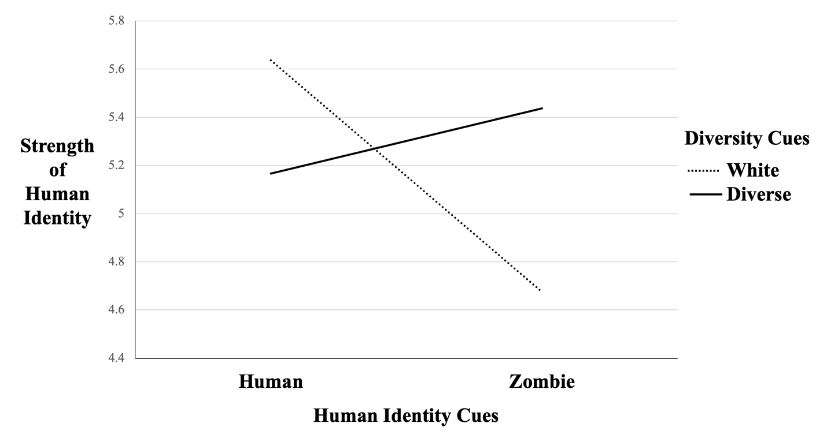

Table 2
Hypothesized Direct and Indirect Effects
Direct and Indirect Paths | Coeff. [95% CI] | p-value
DC→Strength of Human Identity | .07[-.21, .34] | .60
HIC→Strength of Human Identity | -.17[-.45, .09] | .21
Strength of Human Identity →Positive Attitudes toward Black People | -.001[-.10, .10] | .99
Strength of Human Identity →Negative Attitudes toward Black People | -.09[-.20, .005] | .08
Positive Attitudes toward Black People→Attitudes toward Other Identity Groups | 2.10[.52, 3.90] | .01
Negative Attitudes toward Black People→Attitudes toward Other Identity Groups | -5.00[-6.58, -3.37] | .00
HIC (moderated by DC)→Strength of Human Identity | 1.23[.17, 2.35] | .03
HIC (with DC present)→Strength of Human Identity | .27[-.54, 1.04] | .49
HIC (with DC absent)→Strength of Human Identity | -.96[-1.72, -.23] | .01
DC (with HIC present)→Strength of Human Identity | .76[-.09, 1.56] | .07
DC (with HIC absent)→Strength of Human Identity | -.47[-1.24, .25] | .21
HIC (moderated by DC)→Strength of Human Identity→Positive Attitudes toward Black People | -.001[-.14, .14] | .99
HIC (with DC present)→Strength of Human Identity→Positive Attitudes toward Black People | -.000[-.06, .05] | .99
HIC (with DC absent)→Strength of Human Identity→Positive Attitudes toward Black People | .001[-.10, .10] | .99
HIC (moderated by DC)→Strength of Human Identity→Negative Attitudes toward Black People | -.11[-.35, -.002] | .07
HIC (with DC present)→Strength of Human Identity→Negative Attitudes toward Black People | -.03[-.15, .03] | .56
HIC (with DC absent)→Strength of Human Identity→Negative Attitudes toward Black People | .09[.003, .27] | .16
HIC (moderated by DC)→Strength of Human Identity→Positive Attitudes toward Black People→Attitudes toward Other Identity Groups | -.002[-.29, .34] | .99
HIC (with DC present)→Strength of Human Identity→Positive Attitudes toward Black People→Attitudes toward Other Identity Groups | -.000[-.12, .11] | .99
HIC (with DC absent)→Strength of Human Identity→Positive Attitudes toward Black People→Attitudes toward Other Identity Groups | .002[-.26, .22] | .99
HIC (moderated by DC)→Strength of Human Identity→Negative Attitudes toward Black People→Attitudes toward Other Identity Groups | .57[.02, 1.92] | .02
HIC (with DC present)→Strength of Human Identity→Negative Attitudes toward Black People→Attitudes toward Other Identity Groups | .13[-.17, .78] | .57
HIC (with DC absent)→Strength of Human Identity→Negative Attitudes toward Black People→Attitudes toward Other Identity Groups | -.45[-1.45, -.01] | .18
Note. DC=Diversity Cues. HIC=Human Identity Cues. Coeff. = coefficients. Diversity cues were recoded as (+1) present and (-1) absent. Human identity cues were recoded as (+1) non-human and (-1) human. Saturated models were estimated, therefore there was no model fit indices to be reported. Coefficients presented here are unstandardized, bias-corrected, and with 5,000 bootstrap samples. 95%CI is presented in the square bracket next to each coefficient. Coefficients that are outside of the sampling error of zero are bolded. P-value is computed with Wald test.

Supplemental material, data, and stimuli associated with the present study are shared on OSF. https://osf.io/b48nf/?view_only=17fc8e56eb6e413f9b830594f8436169
For detailed description of measurement, see online supplemental material.
The association between strength of human identity and negative attitudes toward Black people was marginally significant. This effect was statistically nonsignificant when using 95% CI (see Table 2), but the p-value was .08 which is considered marginally significant.

